***SAIL NEW ENGLAND THIS SUMMER***[**MORE MAGIC**](http://www.more-magic.com/)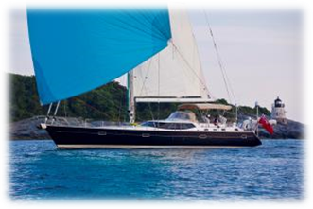

67’ Discovery Yachts - Great yacht and value  
6 guests in 3 double staterooms  
2 crew: Alex and Emma Whicher  
$18,000/wk ++  
[www.charterbrochure.com/moremagic](http://www.charterbrochure.com/moremagic)   
**Available Dates:**   
July 1 (Newport) – July 26 (Maine)  
Aug 7 - 14 (Maine)  
Aug 26 (Maine) – Sept 7

[**MARAE**](http://www.charterbrochure.com/marae) 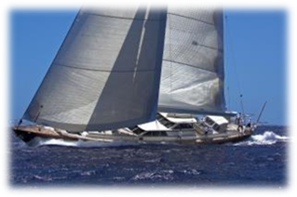108’Alloy Yachts – Fontaine Design – ex Paraiso  
6 guests in 2 double and 1 twin stateroom  
4 crew: Capt. Richard Stalford  
$54,000/wk ++  
[www.charterbrochure.com/marae](http://www.charterbrochure.com/marae)   
**Available Dates:**    
June 22 – 29 (Newport)   
July 9 – 25   
Aug 6 – 28   
Sept 22(Maine) – 30

[**WHISPER**](http://www.charterbrochure.com/whisper) 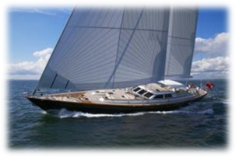116’ HJB – Fontaine Design   
6 guests in 2 double and 1 twin stateroom  
4 crew: Capt. Clive Youlton  
$65,000/wk ++  
[www.charterbrochure.com/whisper](http://www.charterbrochure.com/whisper)   
**Available Dates:**   
Aug 1 – 14 (Newport)

*I look forward to your inquiries!*